Customer Journey Map
The Customer Journey Map shows the complete experience of an employee while submitting and tracking a network request. It helps identify the user’s actions, touchpoints, experience, pain points, and improvement opportunities at each stage. The journey follows the request from submission to completion and closure, matching the structure of the journey-map template you provided.

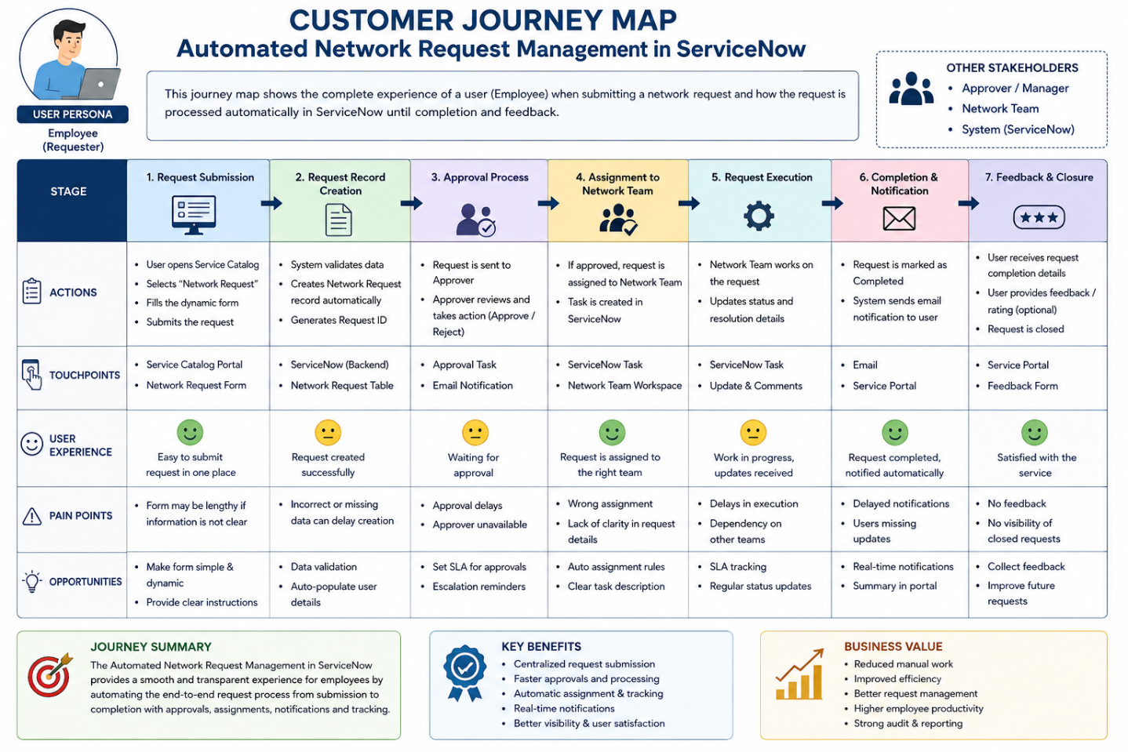

Key Insight:
The system improves the customer journey by reducing manual work, automating approvals and assignments, and providing clear request tracking and notifications.

